(Practice For Final)

Question 1
XYZ limited purchased new non-current asset on 1 June, 2011. The asset is expected to have a 5-year life and $2,000 residual value. The cost of non-current asset is $17,000.
Required
Compute depreciation expense under each depreciation method listed below:
(i). Straight-line method using full year & half year convention.
(ii). 200 percent declining-balance, using full year and the half-year convention.
(iii). 150 percent declining-balance, using full year and the half-year convention.

 | SLM (Full year convention)  (17000 – 2000) = 15000/5 = 3000 | SLM (Half year convention)
Initial cost | 17000 | 17000
Less: Depreciation (Year1) | (3000) | 3000 x 0.5 = (1500)
Net book value (Year 1) | 14000 | 15500
Less: Depreciation (Year 2) | (3000) | (3000)
Net book value (Year 2) | 11000 | 12500
Less: Depreciation (Year 3) | (3000) | (3000)
Net book value (Year 3) | 8000 | 9500
Less: Depreciation (Year 4) | (3000) | (3000)
Net book value (Year 4) | 5000 | 6500
Less: Depreciation (Year 5) | (3000) | (3000)
Net book value (Year 5) | 2000 | 3500
Less: Depreciation (Year 6) |  | 3000 x 0.5 = (1500)
Net book value |  | 2000

 | 200% declining balance (Full year convention)  1/5 = 20% x 200% = 40% | 200% declining balance (Half year convention)
Initial cost | 17000 | 17000
Less: Depreciation (Year1) | 17000 x 40% = (6800) | 17000 x 40% = 6800 x 0.5 = (3400)
Net book value (Year 1) | 10200 | 13600
Less: Depreciation (Year 2) | 10200 x 40% = (4080) | 13600 x 40% = (5440)
Net book value (Year 2) | 6120 | 8160
Less: Depreciation (Year 3) | 6120 x 40% = (2448) | 8160 x 40% = (3264)
Net book value (Year 3) | 3672 | 4896
Less: Depreciation (Year 4) | 3672 x 40% = (1469) | 4896 x 40% = (1958.4 )
Net book value (Year 4) | 2203 | 2937.6
Less: Depreciation (Year 5) | Balancing figure (203) | Balancing figure (937.6)
Net book value (Year 5) | 2000 | 2000

 | 150% declining balance (Full year convention)  1/5 = 20% x 150% = 30% | 150% declining balance (Half year convention)
Initial cost | 17000 | 17000
Less: Depreciation (Year1) | 17000 x 30% = (5100) | 17000 x 30% = 5100 x 0.5 = (2550)
Net book value (Year 1) | 11900 | 14450
Less: Depreciation (Year 2) | 11900 x 30% = (3570) | 14450 x 30% = (4335)
Net book value (Year 2) | 8330 | 10115
Less: Depreciation (Year 3) | 8330 x 30% = (2499) | 10115 x 30% = (3035)
Net book value (Year 3) | 5831 | 7080
Less: Depreciation (Year 4) | *5831- 2000 = 3831/2 = (1916) | *7080- 2000 = 5080/2 = (2540 )
Net book value (Year 4) | 3915 | 4540
Less: Depreciation (Year 5) | (1915) | (2540)
Net book value (Year 5) | 2000 | 2000

* Allocating the remaining book value over the remaining life by the straight-line method does not represent a change in depreciation methods. Rather, a switch to straight-line when this will result in larger depreciation is part of the declining-balance method. This is the way in which we arrive at the desired residual value.

DEP 4 5831 X 30 % = 1749
NBV 4 = 5831 – 1749 = 4082

DEP 5 = 4082 – 2000 = 2082

Question 2
ABC limited purchased non-current asset on July 1, 2001. The asset is expected to have a 20-year life and no residual value. The cost of non-current asset is $20,000.
Required
Compute depreciation expense for the years 2001 through 2004 under each depreciation method listed below:
(i). Straight-line, with fractional years rounded to the nearest whole month.
(ii). 200 percent declining-balance, using the half-year convention.
(iii). 150 percent declining-balance, using the half-year convention.

 | SLM (20000/20)  = $1000 per annum | 200% declining balance (Half year convention)  1/20 = 5% x 200% = 10% | 150% declining balance (Half year convention)  1/20 = 5% x 150% = 7.5%
Initial cost | 20000 | 20000 | 20000
Less: Depreciation (Year 2001) | 2000 x 6/12 = (500) | 20000 x 10% = 2000 x 50% = (1000) | 20000 x 7.5% = 2000 x 50% = (750)
Net book value (Year 2001) | 19500 | 19000 | 19250
Less: Depreciation (Year 2002) | (1000) | 19000 x 10% = (1900) | 19250 x 10% = (1444)
Net book value (Year 2002) | 18500 | 17100 | 17806
Less: Depreciation (Year 2003) | (1000) | 17100 x 10% = (1710) | 17806 x 7.5% = (1335)
Net book value (Year 2003) | 17500 | 15390 | 16471
Less: Depreciation (Year 2004) | (1000) | 15390 x10% = (1539) | 16471 x7.5% = (1235)
Net book value (Year 2004) | 16500 | 13851 | 15236

Question 3

Shown below is the information needed to prepare a bank reconciliation for Titanic Limited at September 30:
1. At September 30, balance as per bank statement was $ 12,350 & cash per the company’s records was $18,500.
2. Three debit memoranda accompanied the bank statement: bank charges for September of $50, a $1,000 check drawn by Rose marked “NSF” & insurance for September $200.
3. Two credit memoranda accompanied the bank statement: investment income for September $700, rent received $400 from Mr. Dawson
4. Cash receipts of $20,000 on September 30 were not deposited until October 5.
5. The following checks had been issued in September but were not included among the paid checks returned by the bank: no. 100 for $2,000, no. 101 for $4,000, and no. 102 for $8,000.
Required
a. Prepare a bank reconciliation At September 30
b. Prepare the necessary journal entries to update the accounting records (Cash Book).
ANSWER
To prepare BRS we firstly need to prepare the adjusted cashbook and then reconcile the adjusted cash book balance with the bank statement balance.

ADJUSTED CASH BOOK
Debit | ($) | Credit | ($)
Un adjusted balance | 18500 | Bank charges | 50
Investment income | 700 | Dishonored check (NSF) | 1000
Rent | 400 | Insurance | 200
 |  | Adjusted balance | 18350
Total | 19600 | Total | 19600

BANK RECONCILIATION STATEMENT
 | ($)
BALANCE AS PER CASH BOOK (Adjusted) | 18350 (DR)
+ UNPRESENTED CHEQUES | 14000
- Receipts not deposited | (20000)
BALANCE AS PER BANK STATEMENT | 12350 (CR)

Journal Entries

Date/ Transactions | Accounts | Debit ($) | Credit ($)
 | Bank charges | 50
 | Bank |  | 50
 | Rose (Receivable) | 1000
 | Bank |  | 1000
 | Insurance | 200
 | Bank |  | 200
 | Bank | 700
 | Investment income |  | 700
 | Bank | 400
 | Rent income |  | 400

Question 4
On 31 December 20X8 the bank column of C Tench’s cash book showed a debit balance of £1,500. The monthly bank statement written up to 31 December 20X8 showed a credit balance of
£2,950.
On checking the cash book with the bank statement it was discovered that the following transactions
had not been entered in the cash book:
Dividends of £240 had been paid directly to the bank.
A credit transfer – Customs and Excise VAT refund of £260 – had been collected by the bank.
Bank charges £30.
A direct debit of £70 for the RAC subscription had been paid by the bank.
A standing order of £200 for C Tench’s loan repayment had been paid by the bank.
C Tench’s deposit account balance of £1,400 was transferred into his bank current account.
A further check revealed the following items:
Two cheques drawn in favour of T Cod £250 and F Haddock £290 had been entered in the cash
book but had not been presented for payment.
Cash and cheques amounting to £690 had been paid into the bank on 31 December 20X8 but were
not credited by the bank until 2 January 20X9.
Required:
(a) Starting with the debit balance of £1,500, bring the cash book (bank columns) up to date and then balance the bank account.
(b) Prepare a bank reconciliation statement as at 31 December 20X8.

Answer

ADJUSTED CASH BOOK
Debit | ($) | Credit | ($)
Un adjusted balance | 1500 | Bank charges | 30
Dividends | 240 | Direct debit | 70
VAT Refund | 260 | Standing order | 200
Deposit account | 1400 | Adjusted balance | 3100
Total | 3400 | Total | 3400

BANK RECONCILIATION STATEMENT
 | ($)
BALANCE AS PER CASH BOOK (Adjusted) | 3100 (DR)
+ UNPRESENTED CHEQUES (250 + 290) | 540
- UNCREDITED CHEQUES | (690)
BALANCE AS PER BANK STATEMENT | 2950 (CR)

Question 5

Mach IV Audio uses a periodic inventory system. One of the store’s most popular products is an MP3 car stereo system. The inventory quantities, purchases, and sales of this product for the most recent year are as follows:

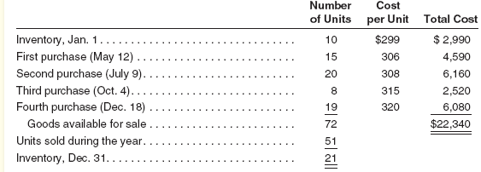
All units were sold @ 500 per unit on 31st December
(a) Compute the cost of the December 31 inventory and the cost of goods sold for the MP3 systems during the year under each of the following cost flow assumptions:
1. First-in, first-out.
2. Last-in, first-out.
3. Average cost (If periodic inventory system is used).
(b) Pass necessary journal entries for each method
(c) Calculate gross profit under each method

Answer

Details | ($)
Sales (51 x 500) | 25500
Opening inventory = (10 x 299) | 2990
Purchases = (15 x 306) + (20 x 308) + (8 x 315) + (19 x 320) | 19350
FIFO  COGS= (10 x 299) + (15 x 306) + (20 x 308) + (6 x 315)  CI = (2 X 315) + (19 X 320) | 15630  6710
LIFO  COGS= (10 x 299) + (15 x 306) + (20 x 308) + (6 x 315)  CI = (2 X 315) + (19 X 320) = (11 X 306) + (10 X 299) | 15984  6356
Average cost (Periodic Inventory System)  Closing Inventory rate = (2990 + 19350)/ 72 = 310.27777  COGS= (51 x 310.277777)  CI = (21 x 310.277777) | 15824  6516

JOURNAL ENTRIES

Date/ Transactions | Accounts | Debit ($) | Credit ($)
Purchases | Inventory (4590 + 6160+ 2520 + 6580) | 19350
 | Cash |  | 19350
SALES | Cash | 25500
 | Sales |  | 25500
FIFO | Cost of goods sold | 15630
 | Inventory |  | 15630
 | Closing Inventory | 6710
 | Cost of goods sold |  | 6710
LIFO | Cost of goods sold | 15984
 | Inventory |  | 15984
 | Closing Inventory | 6356
 | Cost of goods sold |  | 6356
AVCO | Cost of goods sold | 15824
 | Inventory |  | 15824
 | Closing Inventory | 6516
 | Cost of goods sold |  | 6516

Gross profit calculation

 | ($) FIFO | ($) LIFO | ($) AVCO
Sales | 25500 | 25500 | 25500
Opening inventory | 2990 | 2990 | 2990
Purchases | 19350 | 19350 | 19350
Closing inventory | (6710) | (6356) | (6516)
Cost of goods sold | 15630 | 15984 | 15824
Gross profit (Sales – Cost of goods sold) | 9870 | 9516 | 9676

QUESTION 6
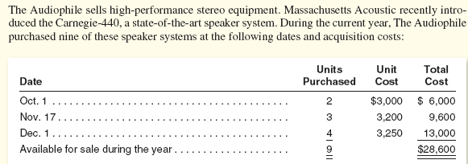
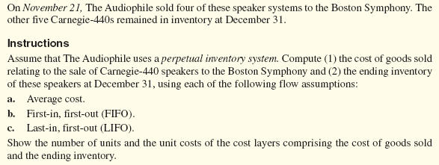
Answer
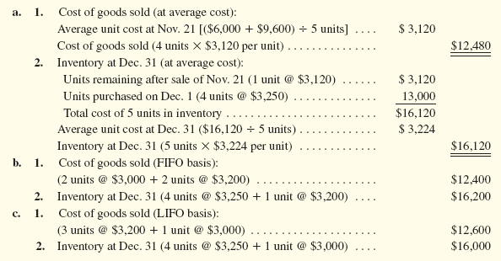
Question 7

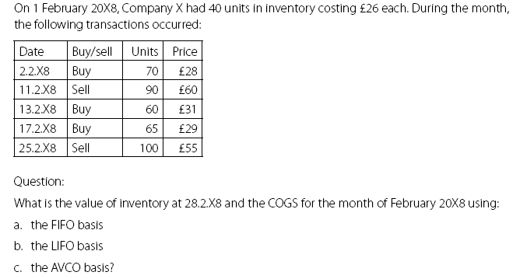
d. Calculate the gross profit of the business also by all 4 methods
ANSWER
(a) FIFO
DATE | PURCHASES | ISSUES | BALANCE
1-2-08 |  |  | 40 26 1040
2-2-08 | 70 28 1960 |  | 40 26 1040  70 28 1960
11-2-08 |  | 40 26 1040  50 28 1400 | 20 28 560
13-2-08 | 60 31 1860 |  | 20 28 560  60 31 1860
17-2-08 | 65 29 1885 |  | 20 28 560  60 31 1860  65 29 1885
25-2-08 |  | 20 28 560  60 31 1860  20 29 580 | 45 29 1305

(b) LIFO

DATE | PURCHASES | ISSUES | BALANCE
1-2-08 |  |  | 40 26 1040
2-2-08 | 70 28 1960 |  | 40 26 1040  70 28 1960
11-2-08 |  | 70 28 1960  20 26 520 | 20 26 520
13-2-08 | 60 31 1860 |  | 20 26 520  60 31 1860
17-2-08 | 65 29 1885 |  | 20 26 520  60 31 1860  65 29 1885
25-2-08 |  | 65 29 1885  35 31 1085 | 20 26 520  25 31 775

(c) PERIODIC WAC
Closing stock rate
= (OPENING STOCK COST + PURCHASES COST)
(OPENING STOCK UNITS + PURCHASED UNITS)
= (1040 +5705) = $28.7 per unit
(40 +195)
CLOSING STOCK VALUE = Closing stock rate x Closing stock units
28.7 X 45 UNITS = $1,292 APPROXIMATELY

(c) PERPEETUAL WAC
DATE | PURCHASES | ISSUES | BALANCE
1-2-08 |  |  | 40 26 1040
2-2-08 | 70 28 1960 |  | 110 27.28 3000
11-2-08 |  | 90 27.28 2455 | 20 27.2 545
13-2-08 | 60 31 1860 |  | 80 30.06 2405
17-2-08 | 65 29 1885 |  | 145 29.59 4290
25-2-08 |  | 100 29.59 2959 | 45 29.59 1331

(d) INCOME STATEMENT

DETAILS | FIFO ($) | LIFO ($) | PERIODIC WAC ($) | PERPETUAL WAC ($)
SALES  (90 X 60) + (100 X 55) | 10900 | 10900 | 10900 | 10,900
LESS: COST OF SALES:
OPENING STOCK | 1040 | 1040 | 1040 | 1040
+ PURCHASES | 5705 | 5705 | 5705 | 5705
-CLOSING STOCK | (1305) | (1295) | (1292) | (1331)
COS (TOTAL) | 5440 | 5450 | 5453 | 5414
GROSS PROFIT | 5460 | 5450 | 5447 | 5486
Question 8

XYZ Limited is a manufacturer that makes all sales on 30-day credit terms. Annual sales are approximately $10 million. At the end of 2019, accounts receivable were presented in the company’s balance sheet as follows:

Accounts Receivables from the Clients $ 900,000
Less: Allowance for doubtful accounts $20,000

During 2020, $57,500 of specific accounts receivable were written off as uncollectible. Of these accounts written off, receivables totaling $4,500 were subsequently collected. At the end of 2020, it was indicated that there is a need for a $37,500 allowance to cover possible failure to collect the accounts currently outstanding. XYZ Limited makes adjusting entries for uncollectible accounts only at year-end.

Required:
(a) Prepare the following journal entries:
1. Entry for all accounts written off against the Allowance for Doubtful Accounts during 2020.
2. Entries to record the accounts receivable that were subsequently collected.
3. The adjusting entry required at the year-end 2020 for Allowance for Doubtful Accounts.
(b) Prepare the T accounts of Uncollectible account, Accounts Receivable and Allowances for doubtful debts for the year 2020.
(c) Also prepare the extracts of PL and balance sheet for 2020.

Answer

Transaction | Account | Debit ($) | Credit ($)
1 | Allowance for doubtful debts | 57500
 | Accounts receivable |  | 57500
2 | Accounts receivable | 4500
 | Allowance for doubtful debts |  | 4500
 | Cash | 4500
 | Accounts receivable |  | 4500
3 | Uncollectable (bad debts) Account | 70500
 | Allowance for doubtful debts |  | 70500

Accounts Receivable Account
Debit | ($) | Credit | ($)
Opening balance | 900000 | Allowances | 57500
Allowances | 4500 | Cash | 4500
 |  | Closing balance | 842500
Total | 904500 | Total | 904500

Allowances for Doubtful Debts Account
Debit | ($) | Credit | ($)
Accounts receivable | 57500 | Opening balance | 20000
 |  | Accounts receivable | 4500
Closing balance | 37500 | Bad debts | 70500
Total | 95000 | Total | 95000

Bad Debts Account
Debit | ($) | Credit | ($)
Allowances | 70500 | PL | 70500
Total | 70500 | Total | 70500

Extract
Income statement (PL) | 2020 ($)
Bad debts | 70500
SOFP
Account receivable | 842500
Less: Allowances | (37500)
Net receivables | 805000

Question 9
The following information relates to XYZ
 | January ($) | February ($) | March ($)
Accounts Receivable | 250000 | - | -
Bad debts (written off) | - | 4000 | 2000
Bad debts recovered | - | - | 500
Uncollectible estimate | 10000 | 11000 | 16000

Pass journal entries. Also prepare T accounts & Extracts.
Answer
Details | Account | Debit ($) | Credit ($)
January | Uncollectable Account | 10000
 | Allowance for doubtful debts |  | 10000
February | Allowance for doubtful debts | 4000
 | Accounts receivable |  | 4000
 | Uncollectable Account | 5000
 | Allowance for doubtful debts |  | 5000
March | Allowance for doubtful debts | 2000
 | Accounts receivable |  | 2000
 | Accounts receivable | 500
 | Allowance for doubtful debts |  | 500
 | Cash | 500
 | Accounts receivable |  | 500
 | Uncollectable Account | 6500
 | Allowance for doubtful debts |  | 6500

Accounts Receivable Account
 | Debit | ($) | Credit | ($)
January | Sales | 250000 | Closing balance | 250000
 | Total | 250000 | Total | 250000
February | Opening balance | 250000 | Allowances For DD | 4000
 |  |  | Closing balance | 246000
 | Total | 250000 | Total | 250000
March | Opening balance | 246000 | Allowances For DD | 2000
 | Allowances For DD | 500 | Cash | 500
 |  |  | Closing balance | 244000
 | Total | 246500 | Total | 246500

Uncollectible Account
 | Debit | ($) | Credit | ($)
January | Allowances for DD | 10000 | PL | 10000
February | Allowances for DD | 5000 | PL | 5000
March | Allowances for DD | 6500 | PL | 6500

Allowances for Doubtful Debts Account
Debit | ($) | Credit | ($)
Closing balance | 10000 | Uncollectible | 10000 | January
Total | 10000 | Total | 10000
Accounts receivable | 4000 | Opening balance | 10000 | February
Closing balance | 11000 | Uncollectible (b/f) | 5000
Total | 15000 | Total | 15000
Accounts receivable | 2000 | Opening balance | 11000 | March
 |  | Accounts receivable | 500
 |  | Uncollectible (b/f) | 6500
Closing balance | 16000
Total | 18000 | Total | 18000

Extracts
Income statement | January ($) | February ($0 | March ($)
Uncollectible | 10000 | 5000 | 6500
SOFP
Account receivable | 250000 | 246000 | 244000
Less: Allowances | 10000 | 11000 | 16000
Net receivables | 240000 | 235000 | 228000

EXAMPLE 10
State whether each of the following is TRUE or FALSE WITH REASONS

(1) Prepaid expenses are deducted from related expense in income statement.
(2) Accrued income and outstanding income is same
(3) Prepaid income and payable income is same
(4) Accrued incomes are added in related expenses.
(5) Accrued expenses are recognized as assets on the balance sheet.
(6) Cash book and pass book are same.
(7) Reconciliation between cash book and bank statement is always perfect.
(8) Balance as per cash book OVERDRAWN is always debit
(9) Balance as per bank statement OVER DRAWN is always credit
(10) Adjusted cash book had a plus side payments and minus side receipts.
(11) Straight line depreciation means depreciation on net book value always.
(12) Diminishing balance method means depreciation on original cost always.
(13) Disposal gain is credited in profit & loss account.
(14) Disposal account is always balanced.
(15) Non- current assets are always shown at cost in balance sheet.
(16) Cash withdrawn for business use is called drawings
(17) Goods withdrawn for personal use are called drawings
(18) Purchases are made always on cash or credit basis only.
(19) Statement financial position is prepared for a particular period of time.
(20) Income statement shows financial performance of business on a particular day.
(21) Balance sheet shows financial performance of the business on a particular day.
(22) Bank overdraft is a non-current liability
(23) Highly Liquid investments and Bank balance are cash equivalents.
(24) Cash will always have a debit balance in trail balance.
(25) Trail balance is always equal.
(26) Cost is always less then Net realizable value of inventory.
(27) Inventory is valued at lower of cost or NRV.
(28) International accounting standard (IAS 2) recommend FIFO and LIFO method for inventory valuation.
(29) Matching means matching of assets and liabilities
(30) Prudence means to record future expenses, but not future incomes.
(31) Closing stock is less liquid than Debtors
(32) Cash is most liquid current asset
(33) Duality concept focuses on debit and credit aspects of accounting transactions.
(34) Amount provided by outsiders to business is called capital.
(35) Assets + Liabilities = Capital
(36) Main reason of providing depreciation is the wear & tear in asset.
(37) Equity = opening capital + additions in capital + net profit – drawings
(38) Financial accounting includes all transactions (Financial and Non-financial)
(39) There are two main branches of ACCOUNTING. Financial accounting & Management accounting.
(40) Return inwards has a credit balance
(41) Return outwards had a credit balance
(43) Bank loan is a short term liability
(44) NRV = ESTIMATED SELE PRICE + ESTIMATED COST TO COMPLETE SALE + ESTIMATED SELLING COST
(45) Bank charges are always credited in cash book.
(46) Bad debts can never be recovered.
(47) The value of allowances for doubtful debts is always greater than bad debts
(48) ALLOWANCES for doubtful debts has a credit balance in trail balance.
(49) Adjusted trail balance is always equal.
(50) Bad debts recovered means cash debit and income credit

ANSWERS.

False. Prepaid expenses are not deducted from related expenses on the income statement. Instead, they are recorded as assets on the balance sheet and then expensed in the period when the service is actually consumed.

False. Accrued income refers to income that has been earned but not yet received, while outstanding income often refers to income that is due and expected but not yet received. The terms are similar but not identical.

False. Prepaid income is income received in advance for services yet to be provided, while payable income generally refers to income that is due to be paid out.

False. Accrued incomes are not added to related expenses. They are incomes that have been earned but not yet received and are recorded as assets.

False. Accrued expenses are recognized as liabilities on the balance sheet, not assets.

False. The cash book records the company's cash transactions, while the passbook is a record provided by the bank, showing the bank's view of the company's transactions.

False. Reconciliation between a cash book and a bank statement is not always perfect due to timing differences, errors, and omissions.

True. If the balance as per the cash book is overdrawn, it means there is a negative balance, which is represented as a debit.

True. An overdrawn balance as per the bank statement is a liability to the bank and therefore shown as a credit.

False. An adjusted cash book reflects all transactions: receipts on the plus side and payments on the minus side, not the other way around.

False. Straight-line depreciation means depreciating an asset by a fixed amount each year, not necessarily on the net book value.

False. Diminishing balance method means depreciating an asset based on a fixed percentage of its remaining book value each year, not on its original cost.

True. A disposal gain is credited in the profit & loss account as it represents an income.

False. A disposal account may not always be balanced; it depends on the book value of the asset disposed of and the proceeds from the disposal.

False. Non-current assets can be shown at cost or revalued amounts in the balance sheet, depending on the accounting policies adopted.

False. Cash withdrawn for business use is not called drawings; drawings refer to amounts taken out of the business by the owner for personal use.

True. Goods withdrawn for personal use by the owner are recorded as drawings.

True. Purchases are typically made either on cash or on credit.

False. The statement of financial position (balance sheet) is prepared as of a specific date, not for a period.

False. The income statement shows the financial performance of a business over a period, not on a specific day.

False. The balance sheet shows the financial position of a business on a specific day, not its performance.

False. A bank overdraft is typically considered a current liability since it is usually repayable on demand or within a short period.

True. Highly liquid investments and bank balances are often considered cash equivalents due to their high liquidity and low risk of changes in value.

True. Cash is an asset and will normally have a debit balance in the trial balance.

False. The trial balance may not always be equal, especially if there are errors in recording transactions.

False. The cost can be more than or less than the net realizable value of inventory; it's not always less.

True. Inventory is valued at the lower of cost or net realizable value (NRV) according to most accounting standards.

False. IAS 2 discourages the use of LIFO (Last In, First Out) for inventory valuation but recommends FIFO (First In, First Out) or weighted average cost method.

False. Matching in accounting means matching revenues with the expenses that brought them in the same period, not matching assets and liabilities.

True. Prudence in accounting means recognizing expenses and liabilities as soon as possible, but not recognizing revenues and assets until they are assured.

True. Closing stock is typically less liquid than debtors as it may take time to sell the inventory.

True. Cash is considered the most liquid current asset as it is readily available for use.

True. The duality concept in accounting states that every transaction has a dual impact, i.e., debit and credit.

False. Amounts provided by outsiders to a business are liabilities or equity, not necessarily capital, which typically refers to owner's investment.

False. The accounting equation is Assets = Liabilities + Equity (or Capital for sole proprietorships).

True. Depreciation is provided primarily due to wear and tear of an asset over its useful life.

True. Equity is calculated as opening capital plus additions in capital, plus net profit, minus drawings.

False. Financial accounting records only financial transactions, not non-financial ones.

True. The two main branches of accounting are financial accounting and management accounting.

True. Return inwards (sales returns) typically have a credit balance as they reduce the total sales.

False. Return outwards (purchase returns) typically have a debit balance as they reduce the total purchases.

False. A bank loan is typically a long-term liability unless it's specifically a short-term arrangement.

False. NRV is calculated as the estimated selling price minus the estimated cost to complete and sell.

True. Bank charges are expenses and are typically credited in the cash book when the bank deducts them from the account.

False. Bad debts, once written off, can sometimes be recovered at a later date.

False. The value of allowances for doubtful debts is a provision and could be less or more than actual bad debts, depending on the estimation.

True. Allowances for doubtful debts have a credit balance in the trial balance as it's a provision against debtors.

True. An adjusted trial balance should always be equal, as it reflects all adjustments made to the accounts.

True. Bad debts recovered are recorded as cash (debit) and income (credit) as it is an unexpected income.

(ADJUSTED TRAIL BALANCE & FINANCIAL STATEMENTS)
Practice Question
XYZ Inc., provides employment consulting services. The company adjusts its accounts monthly but performs closing entries annually on December 31. The entries for December has not been made. The unadjusted trail balance is as follows:
XYZ
UNADJUSTED TRAIL BALANCE
AS ON 31-12-2011
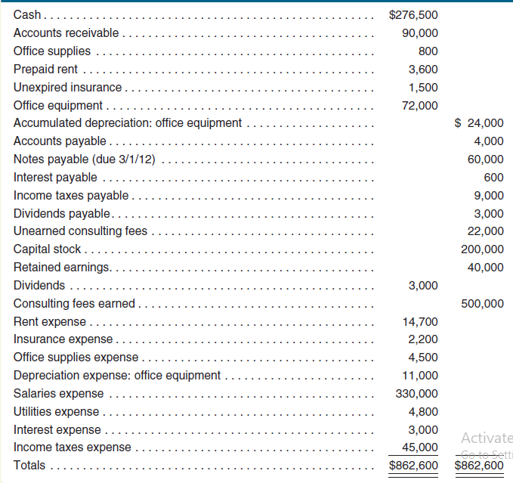
THE FOLLOWING ADJUSTEMENTS ARE REQUIRED AT YEAR END:
(1) Accrued consulting fee: It means income due but not received as yet till the reporting date
1. Accrued but unrecorded and uncollected consulting fees earned total $25,000 at December 31, 2011
Debit: Accounts Receivable 25000
Credit: Consulting Fee Earned 25000
(To record accrued revenue in December)
(2) Unearned (consulting fee):
It means fee was received in advance but we have to give services to the other party.
2. The company determined that $15,000 of previously unearned consulting services fees had been earned at December 31, 2011.

Debit: UNEARNED CONSULTING FEE 15000
Credit: CONSULTING FEE EARNED 15000
(To convert unearned revenue into earned revenue in December)
(3) Office supplies (Current asset)
These are current assets. As we use them we need to expense them.
3. Office supplies on hand at December 31 total $300.
(800 – 300)= 500
Debit: OFFICE SUPPLIES EXPENSE 500
Credit: OFFICE SUPPLIES 500
(To record office supplies used in December)
(4) Equipment (Non-Current Asset) & depreciation)
Depreciation needs to be recorded on non-current assets at each year end
4. The company purchased all of its equipment when it first began business. At that time, the estimated useful life of the equipment was six years (72 months).
72000/ 72 = 1000 PER MONTH
Already recoded = 1000 x 11 = 11000 (see depreciation expense)
To be recorded for December = 1000
Debit: DEPRECIATION EXPENSE 1000
Credit: ACCUMULATED DEPRECIATION 1000
(To record depreciation in December)
(5) Prepaid rent expense
It means rent paid in advance but benefit yet to be received
5. The company prepaid its nine-month rent agreement on June 1, 2011.
Time period for rent is 1-6-2011 to 28-2-2012
Payment has to be made for December 2023. So 3600 represents prepayment for remaining 3 months. 3600 / 3 = 1200
Debit: RENT EXPENSE 1200
Credit: PREPAID RENT 1200
(To record rent expense for December)
(6) Prepaid/Unexpired insurance expense
It means insurance paid in advance but benefit yet to be received.
6. The company prepaid its six-month insurance policy on December 1, 2011.
1500/6 = 250 per month. We need to record insurance for December only
Debit: INSURANCE EXPENSE 250
Credit: PREPAID / UNEXPIRED INSURANCE 250
(To record insurance expense of December only)
(7) Accrued salaries expense
It means salaries due but not paid by the company.
7. Accrued but unpaid salaries total $12,000 at December 31, 2011.
Debit: SALARIES EXPENSE 12000
Credit: SALARIES PAYABLE 12000
(To record unpaid salaries in December)

(8) Interest on loan
Interest on loan needs to be recorded at balance sheet date as an expense and liability
8. On September 1, 2011, the company borrowed $60,000 by signing an eight-month, 4 percent note payable. The entire amount, plus interest, is due on March 1, 2012.
60000 X 4% = `2400/12 = 200 per month
600 already recorded from September to November (see interest payable)
Debit INT EXPENSE 200
Credit: INT PAYABLE 200
(To record interest expense of December)
(9) Taxation
Tax needs to be recorded at balance sheet date as an expense and liability
9. The company’s accounting firm estimates that income taxes expense for the entire year is $50,000. The unpaid portion of this amount is due early in 2012.
45000 already recorded in trail balance as expense. So we need to record for December only. 50000 – 45000 = 5000
Debit: TAX EXPENSE 5000
Credit: TAX PAYABLE 5000
(To record tax expense of December)

ADJUSTED TRAIL BALANCE

Accounts | Debit ($) | Credit ($)
Cash 276500 | 276500
Accounts receivable 90000 +25000 | 115000
Office supplies 800 -500 | 300
Prepaid rent 3600 -1200 | 2400
Unexpired insurance 1500 - 250 | 1250
Office equipment 72000 | 72000
Accumulated depreciation (office quipment) 24000+1000 |  | 25000
Accounts payable 4000 |  | 4000
Notes payable 60000 |  | 60000
Interest payable 600 +200 |  | 800
Income tax payable 9000 +5000 |  | 14000
Dividend payable 3000 |  | 3000
Unearned consulting fees 22000 -15000 |  | 7000
Salaries payable 0 +12000 |  | 12000
Capital stock 200000 |  | 200000
Retained earnings 40000 |  | 40000
Dividends paid 3000 | 3000
Consulting fees earned 500000 +25000 +15000 |  | 540000
Rent expense 14700 + 1200 | 15900
Insurance expense 2200 +250 | 2450
Office supplies expense 4500 + 500 | 5000
Depreciation expense (office equipment) 11000 +1000 | 12000
Salaries expense 330000 +12000 | 342000
Utilities expense 4800 | 4800
Interest expense 3000 +200 | 3200
Income tax expense 45000 + 5000 | 50000
Total | 905800 | 905800

Income Statement
 | ($)
Revenue:
Consulting fee earned / Revenue | 540000
Expenses:
Rent | (15900)
Insurance | (2450)
Office supplies expense | (5000)
Depreciation: office supplies | (12000)
Salaries | (342000)
Utilities | (4800)
Interest | (3200)
Income before tax | 154650
Tax expense | (50000)
Net income (Income after tax) | 104650

Statement of Retained Earnings (Profit statement)

 | ($)
Opening balance retained earnings (from adjusted TB) | 40000
+ Net income | 104650
- Dividends (profit paid to owners/ shareholders) | (3000)
Closing balance retained earnings | 141650

Balance Sheet
 | ($)
Assets:
Cash | 276500
Accounts receivable | 115000
Office supplies | 300
Prepaid rent | 2400
Unexpired/prepaid insurance | 1250
Office equipment less: Accumulated depreciation (72000 – 25000) | 47000
Total assets | 442450
Liabilities:
Accounts payable | 4000
Notes payable | 60000
Interest payable | 800
Income tax payable | 14000
Dividend payable | 3000
Salaries payable | 12000
Unearned consulting fee | 7000
Total liabilities | 100800
Equity
Capital stock(shares) | 200000
Closing balance retained earnings | 141650
Total Equity | 341650
Total Liabilities & Equity (100800 + 341650) | 442450

